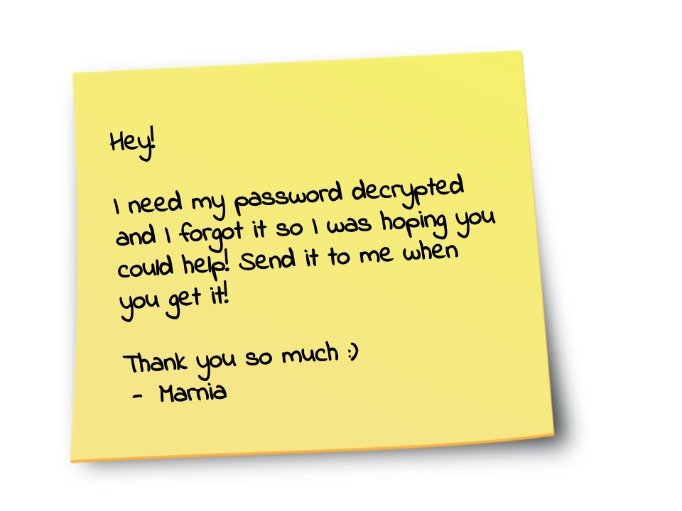

**HINTS: USE THE FILE IN SLACK**